# Loan eligibility Prediction

Loan create a big revenue generation for banks in terms of interest that are applied to loan amount.  
  
**Criteria for eligibility**

1. Loan amount
2. Dependents
3. Marital status
4. Applicant income
5. Loan amount term
6. Co-applicant income
7. Gender
8. Credit history
9. Property area

**Flowchart for approval of Loan.**

Step 1: Loan application

Step 2: Document submission

Step 3: Document Verification

Step 4: Loan approval

**Algorithm Used**

**Decision tree algorithm**

A decision tree is a popular machine learning algorithm used for classification and regression tasks. It works by recursively splitting the dataset into subsets based on the most important features, creating a tree-like structure to make predictions. Here, I'll explain the key concepts of decision trees and provide a simple Python implementation.

1. **Decision Tree Splitting:** The algorithm recursively selects the best feature to split on based on information gain. It continues until a stopping criterion is met, such as a maximum tree depth or a minimum number of samples in a leaf node.
2. **Leaf Nodes:** When a leaf node is reached, it predicts the majority class for classification problems or the mean value for regression problems.

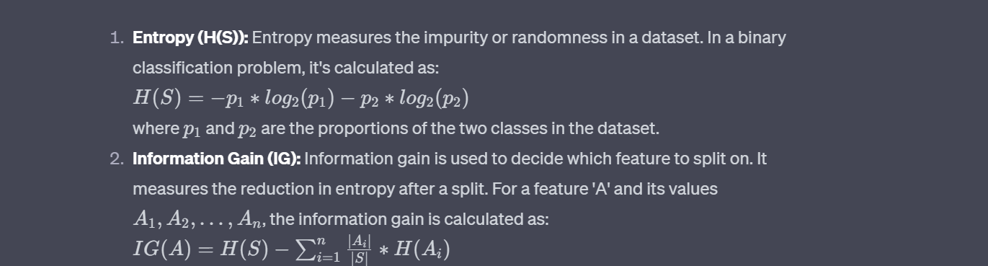

**Naive Bayes Classification**

Naive Bayes is a classification algorithm in machine learning that is based on Bayes' theorem. It's particularly popular for text classification tasks, spam detection, and other applications where the input data can be represented as a bag of words or features. Let's break down the key concepts and formulas involved in Naive Bayes classification with easy explanations:

